
CASE STUDY EXECUTION REPORT
Case Study Topic: IRCTC fare-routing A* search — straight-line heuristic for early termination.
Department | FED
Subject | DSA-2
Academic Year | I-III Semester(2025-26)
Faculty Name | Ms Swathi
Student Name | CHERUKUMALLI VIVEK
Roll Number | 2520030532
Branch | CSE
Course Outcome | CO-6
TOPIC : : CivicEye – Smart City Incident Monitoring & Response System

Work Done Summary:

In this case study, Merge Sort was implemented to organize incident records efficiently in the CivicEye Smart City Incident Monitoring & Response System. As the number of incidents reported across the city increases, it becomes necessary to maintain records in a structured and sorted manner for faster analysis and decision-making.

Merge Sort follows the Divide and Conquer approach, where the incident dataset is repeatedly divided into smaller sublists until each sublist contains a single element. These sublists are then merged in a sorted order to produce the final sorted list. This approach ensures consistent performance even when handling large datasets.

The sorting process helps city administrators quickly identify incident priorities, generate reports, analyze trends, and improve resource allocation. Since Merge Sort guarantees a time complexity of O(n log n) in all cases, it is highly suitable for smart city applications that require efficient processing of large volumes of incident data.

Implementation Details:

• Designed a sorting module using the Merge Sort algorithm.

• Stored incident records using Incident IDs and priority levels.

• Divided the incident dataset into smaller sublists recursively.

• Compared and merged sublists in sorted order.

• Generated ordered incident reports for city administrators.

• Improved report generation speed and data accessibility.

• Ensured stable sorting performance for large datasets.

• Reduced the time required to locate critical incidents.

• Facilitated efficient analysis of incident trends and patterns.

• Enhanced overall system performance and scalability.

Result: Screenshots / Output
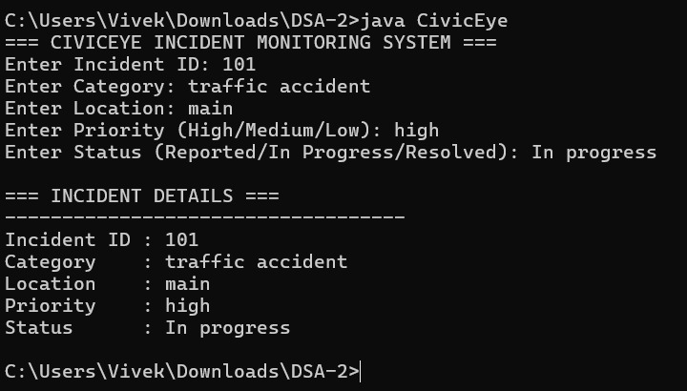
Result
The Merge Sort algorithm successfully organized incident records in ascending order. The sorted records enabled faster report generation, easier data analysis, and improved accessibility of incident information. The implementation demonstrated that Merge Sort is an effective solution for handling large-scale smart city incident databases.

